Navigating & Posting to Philamb.org website

Go to www.philamb.org
On the right hand side there is a link that says “create an account”
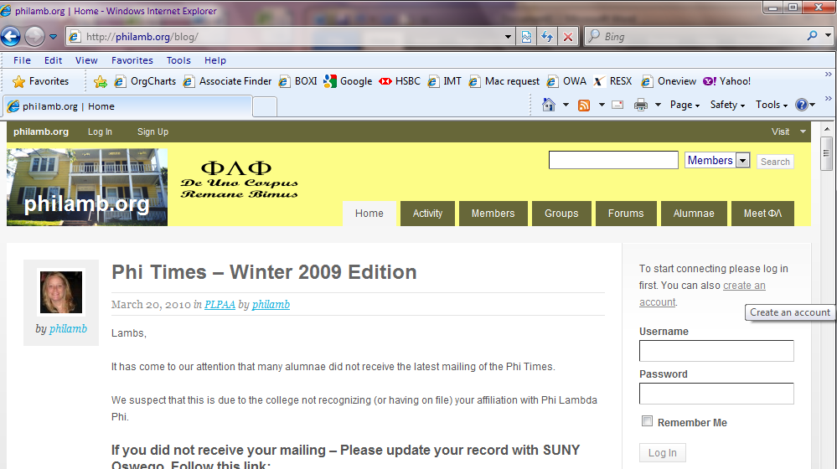
Click the “Create an account” button and build your profile. You can choose a screen name, and required information includes your name, maiden name and pledge class.
Your “Avatar” is your profile picture. Similar to Facebook you can upload a picture of yourself. Hit browse, choose an image on your computer and hit “upload”.
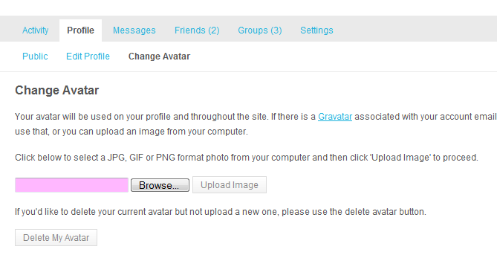

You can go to the Members page and view who else has signed up. You can “friend” them. At the top left under “Notifications” you will see requests from other members requesting your friendship.
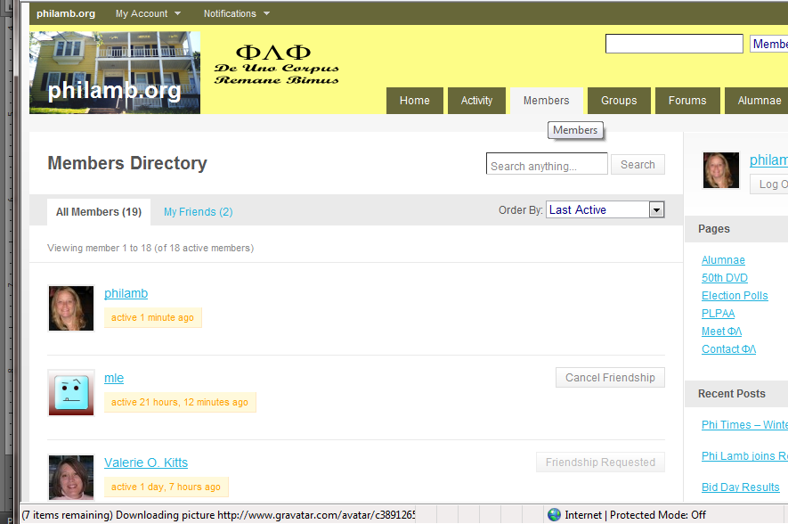
This allows you to invite a member to one of your Groups. Groups allows you to post and share information with other members of that Group. This can be a private or a public group.
The ΦΛΦ Sisters Group is a public group. Anyone can post and share information here.
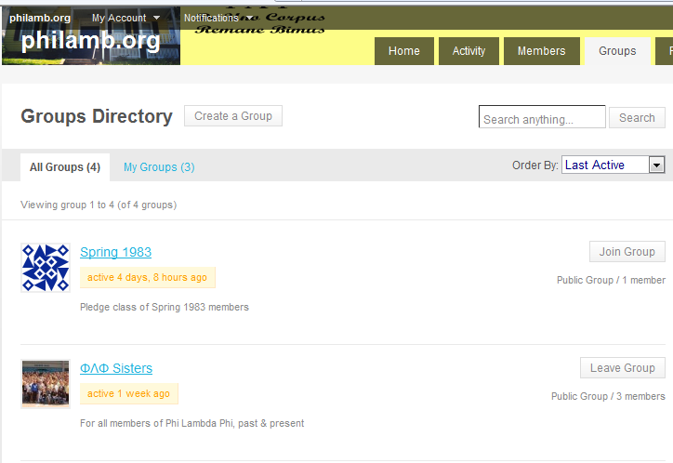

Remember that you can comment anywhere on the site you wish.
If you scroll down the bar on the right hand side, you will see recent comments :

Your comment will appear here.
  - Posting on philamb.org
If you would like me to post an announcement or article, I can do this at any time. Just send me the text and any image(s) or media you want included and I will post for you. You can submit this to philamb@philamb.org
In the meantime – you can post to the ΦΛΦ Sisters group, as this is a public site viewable by anyone stopping by to the website.
Love in phi lamb,
ΦΛΦ Webmistress, Heather (Smith) Connally Sp’92

